

Table of Contents

Revision History and Change Reference 2

1. Introduction 3

1.1. Purpose 3

2. Pre-Requisites and Worksheets 3

2.1 Before You Begin 3

2.2 Exporting Data to a dump file 4

2.3 Importing data to target database 5

Ex:- $mkdir my_dump_dir $sqlplus Enter User:/ as sysdba SQL>create directory data_pump_dir as ‘/u01/oracle/my_dump_dir’; 5

# Revision History and Change Reference

Document Properties

|  |  |
| --- | --- |
| **Item** | **Description** |
| **Title** | **Oracle Database Migration** |
| **Migration** | Oracle 11g release2 to Oracle 12c release2 |
| **Author** | Harish Kumar Dash |
| **Created Date** | 06/08/2019 |
| **Document Classification** | CONFIDENTIAL |

# 1. Introduction

Oracle database (Oracle DB) is a relational database management system (RDBMS) from the Oracle Corporation. Originally developed in 1977 by Lawrence Ellison and other developers, Oracle DB is one of the most trusted and widely-used relational database engines.

The system is built around a relational database framework in which data objects may be directly accessed by users (or an application front end) through structured query language (SQL). Oracle is a fully scalable relational database architecture and is often used by global enterprises, which manage and process data across wide and local area networks. The Oracle database has its own network component to allow communications across networks.

Oracle DB is also known as Oracle RDBMS and, sometimes, just Oracle.

## 1.1. Purpose

The purpose of this document is to record the migration steps that are performed in the BPM environment during the migration of BPM from V8.5.6 to BAW V19.0.0.1. This document also will be used as a reference when ever the user wants to migrate oracle database from 11g to 12c.

# 2. Pre-Requisites and Worksheets

## 2.1 Before You Begin

Create a directory which stores the dump file of the database and assign the required permissions to that directory. The dump file contains the copy of oracle 11g entire database. We use this dump file to import into oracle 12c database.

To create a directory connect to oracle database as shown below image then execute the below commands which assign permission to the directory too.

## 

## 2.2 Exporting Data to a dump file

To export data from oracle 11g database to a dump file and to import data from dump file to oracle 12c database we use data pump utility(**expdp/impdp** commands). The command is shown in below image. Here TEST_DIR is the directory which we created earlier.

**Ex:-****expdp schema_name/password@sid_name full=Y directory=TEST_DIR dumpfile=exp_schm.dmp logfile=schm.log**

**Here, FULL parameter indicates that the whole database will be exported Directory --> The directory on server in which you want to place the dumpfile DUMPFILE --> The name of dumpfile LOGFILE --> The name of logfile (that logs the status of export process)**

## 

With this the exporting will be done.

**Note :** Before starting import you might need to transfer the dumpfile to the new server (i.e. 12c)

## 2.3 Importing data to target database

To import data from dump file to oracle 12c database again we use data pump utility as mentioned above. Use **impdp** command to import data.

**Note :** Before importing data from dump file to database a database should be exist and we need to create the directory as we did while exporting.

The following example creates a directory in the file system and creates a directory object in the database and grants privileges on the Directory Object to the system user.

## Ex:- **$mkdir my_dump_dir $sqlplus Enter User:/ as sysdba SQL>create directory data_pump_dir as ‘/home/oracle/Desktop/my_dump_dir’;**

**Now grant access on this directory object to SYSTEM user**

**SQL> grant read,write on directory data_pump_dir to system;**

We will now start import of the database into 12c database with the help of impdp utility.

**Ex:-** **impdp schema_name/password@sid_name full=Y directory=TEST_DIR dumpfile=exp_schm.dmp logfile=schm.log**

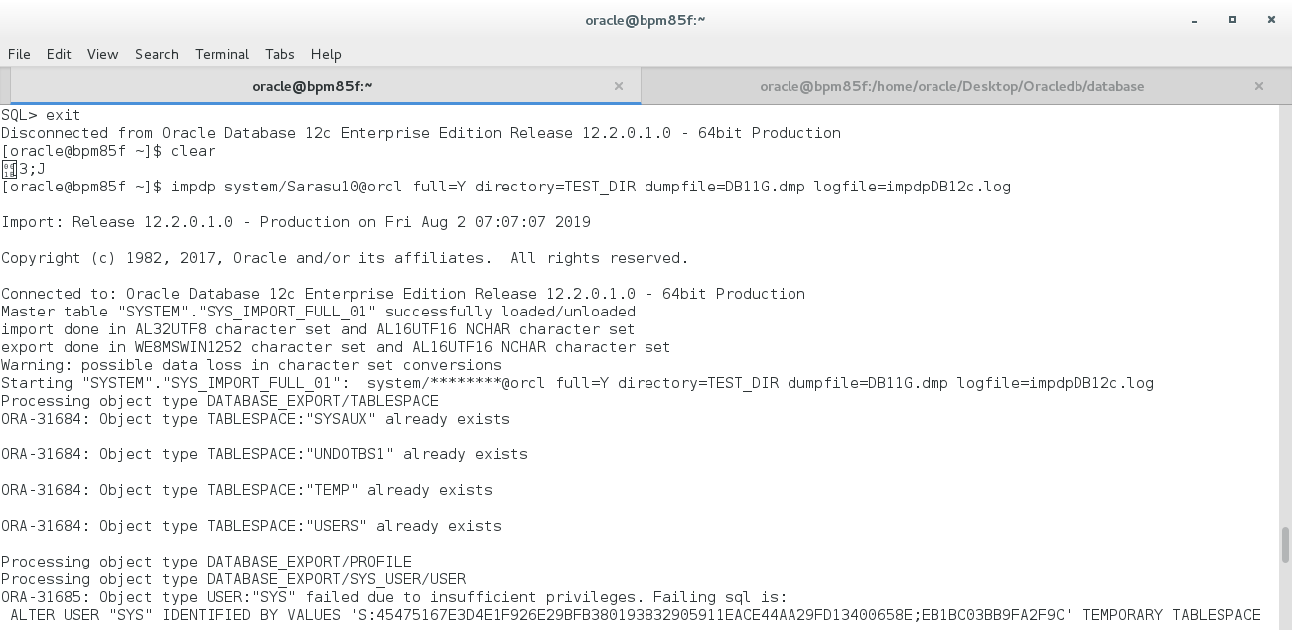

After import has been successfully completed you will get successful completion message.